GTX Leadership Standardized Work Management
Project ID:
Project Requirements Document

Table of Contents
1 Table of Contents 2
2 Project Requirements 3
2.1 Objectives 3
2.2 Scope 3
3 Functional Requirements 4
3.1 New LSW Management fields 4
3.1.1 LSW fields 4
3.1.2 Conditions defining “LSW Function group” to be displayed on LSW Portal as per the Function group leader login. 4
3.1.3 System to capture the login of the user and prepopulate as the Owner name. 4
3.1.4 LSW User should be able to see his tasks for the week, previous week tasks copied to present week if the tasks are in medium and in not closed status. 4
3.1.5 Notifications back to LSW leaders, 4
3.2 SFDC LSW fields. 5
3.2.1 Customized UI for the leaders to assign the tasks.. Fields: 5
3.2.2 LSW Edit form 6
3.2.3 Leadership Standardized Flow -> Design Diagram 6
3.2.4 Benefits 7
4 Assumptions / Limitations 8
4.1 Hierarchy of the leadership levels to be maintained. 8
4.2 Approval process is not required since the leaders are already defined. 8
4.3 Only registered customers have access to “LSW Portal” 8
4.4 If external Customer from non-existing SFDC Account registers at LSW Portal, he will not be able to see / use “LSW Management Portal” – same as he currently doesn’t have access to “LSW Application” 8
5 Parking Lot / Next Phases 8
5.1 Weekly Priorities upgrade. 8
5.2 Reminder schedule. 8
5.3 LSW without interruptions. 9
5.4 LSW UI Redesign – Phase 2 9
6. Appendix 1: “LSW for VP Finance” screenshot 9
7. Appendix 2: “LSW for General Management” screenshot 10
8. Appendix 4: Function Group maintenance for LSW 10
9. Appendix 5: Upload file to LSW 11
10. Appendix 6: Details in IAM Chatter. 11

Project Requirements

Objectives
LSW (Leadership Standardized Work) mainly focuses on materializing the main agenda of the leadership team to their respective team members. The process focuses on the task assignment for the team members of different functional group and to track the progress of those tasks in the system by the leaders. This was earlier done as a paperwork has been now automated in system. The leadership team will have access to assign priorities to their subordinates on week on week basis and monitor the progress of the tasks in system.
Leadership here segmented as a two-level hierarchy on which once the first level role hierarchy assigns the tasks, the flow continues to further levels.

Scope
- Setup LSW customized portal to create the tasks for the team.
- Leaders should have a copy of the previous week record as reference to assign and modify the current task list.
- System should also benefit the user to take an extract of the report on employee vs task basis to analyze the volume of work given to the employee week on week basis.
- Notifications on the task list should be first sent to the leaders end of every week, for them to manage the task for their team well in advance.
- Leaders should able to visualize the tasks and assign them to their teams on time without any delay.
- System should be capable of modifying or deleting the user/owner based on their availability.
- System should be standalone independent from other modules.

Functional Requirements

New LSW Management fields

LSW fields
- OwnerName : Function group Leader Name – mandatory
  - Pre-populated by system per registered user login
- Function Group Name – populated per SFDC Function group
- AOP Goals - mandatory
- STRAP Goals – mandatory
- Weekly Travel
- Week Number

Conditions defining “LSW Function group” to be displayed on LSW Portal as per the Function group leader login.
- “Priorities Sent for the Week?” field = “Yes” once the leaders assigned the tasks for the week.

System to capture the login of the user and prepopulate as the Owner name.

LSW User should be able to see his tasks for the week, previous week tasks copied to present week if the tasks are in medium and in not closed status.

Notifications back to LSW leaders,
- When a LSW is created – to Olivier and Christophe Carli as in the top management.
- When a LSW is assigned – to all the function group leaders once the tasks are assigned from the top management.
- When a LSW is assigned by the function group leaders to their team members, the task list will be sent to the team by email since they will not have the SFDC login access.

SFDC LSW fields.

Customized UI for the leaders to assign the tasks.. Fields:

LSW

- Name
- CurrencyIsoCode
- AOP Goals
- Owner Name
- STRAP Goals
- Headlines
- Weekly Travel
- Week Number

LSW Function Groups

- Delegate To
- FG Name
- Function Group
- Person Responsible
- Is Part of TS LT?

Weekly Priority
- Is Copied from Last Week?
- LSW
- Priority Owner
- Status
- Support
- Week Action

Weekly Travel

- Owner Name
- Function Group Name
- CurrencyISOcode

LSW Edit form
Add next fields under Weekly Priority section; free user input for now
- “Weekly Travel”
- “Owner Name”

Leadership Standardized Flow -> Design Diagram

This is a customized standalone application incorporating the main features of salesforce. It is independent from other modules dedicated only for the leadership team usage.
Hence the design involves mainly the customized objects of sfdc for the flow.

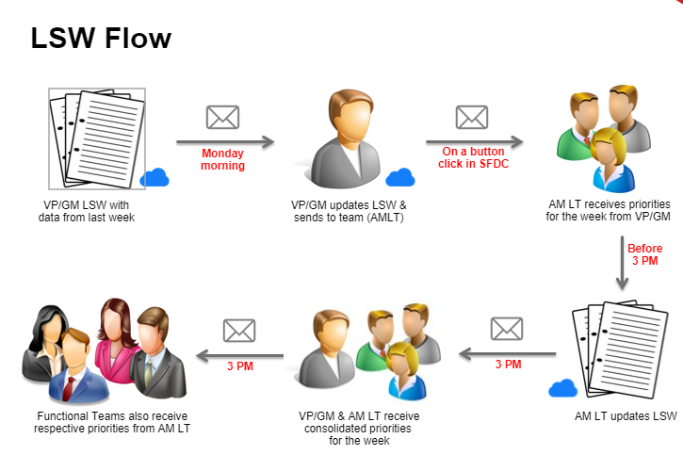

Benefits

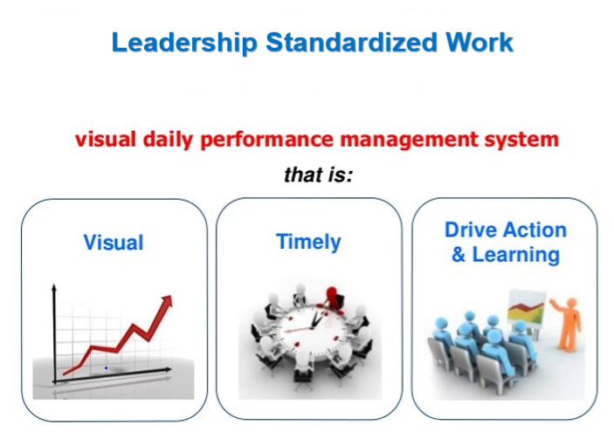
- The leadership team finds it useful as it saves more time for them and avoid the manual process of task assignment.
- This enables the leaders to
- Visualizes the task assigned to the team (both past and present week tasks).
- Assign the tasks to the team on time without any delays as the task assignment becomes automated now.
- The output of which, we can track all the tasks easily and progress better towards closure.
- The time taken to monitor and close the tasks is very minimal now.
- This is a standalone process does not have dependency with any standard objects in salesforce.
- Reusable component and currently it handles to support both EMEA and North America region leadership teams.
- A fully customized process to generate, modify, save and send the task records based on the function groups.
- LSW is an enhanced feature from SFDC specially designed considering the leadership team to
- Assign the tasks to their subordinates as an automated process.
- Have a track of previous week data as reference in assigning the tasks.
- Track history of tasks and its respective status whenever the leader wants.
- Email notifications scheduled at different intervals based on the role hierarchy defined by the leaders. Hence, VP/GM role leaders will assign the tasks to their subordinates. Based on the tasks assigned to them, they will analyze and understand the tasks and assign the child tasks to their subordinates. This is a two-level leadership hierarchy wherein it covers all the top management leaders.

Assumptions / Limitations

Hierarchy of the leadership levels to be maintained.

Approval process is not required since the leaders are already defined.

Only registered customers have access to “LSW Portal”

If external Customer from non-existing SFDC Account registers at LSW Portal, he will not be able to see / use “LSW Management Portal” – same as he currently doesn’t have access to “LSW Application”

Parking Lot / Next Phases

Weekly Priorities upgrade.

Weekly Priorities from the previous week is copied eventhough the task is completed by the user. It has to be tracked in the consolidated version.

Reminder schedule.

Reminder schedule top management on the task assignment if the tasks are not scheduled for the day.
This will enable the leaders to assign the tasks without any delays.

LSW without interruptions.

Even if the tasks are not scheduled, the other leaders has to receive notification on the copy of previous week tasks so they can work on the same.

LSW UI Redesign – Phase 2

6.Appendix 1: “LSW for VP Finance” screenshot
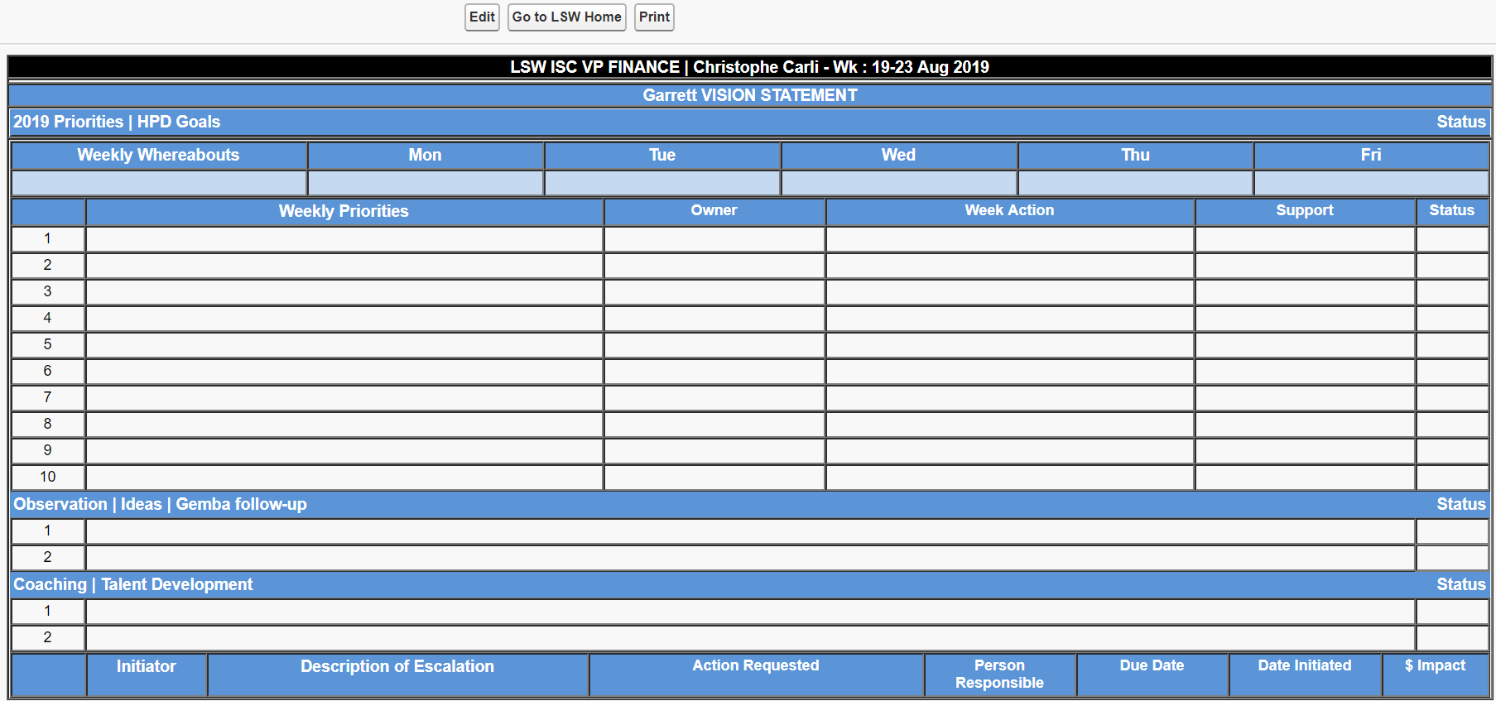

Appendix 2: “LSW for General Management” screenshot
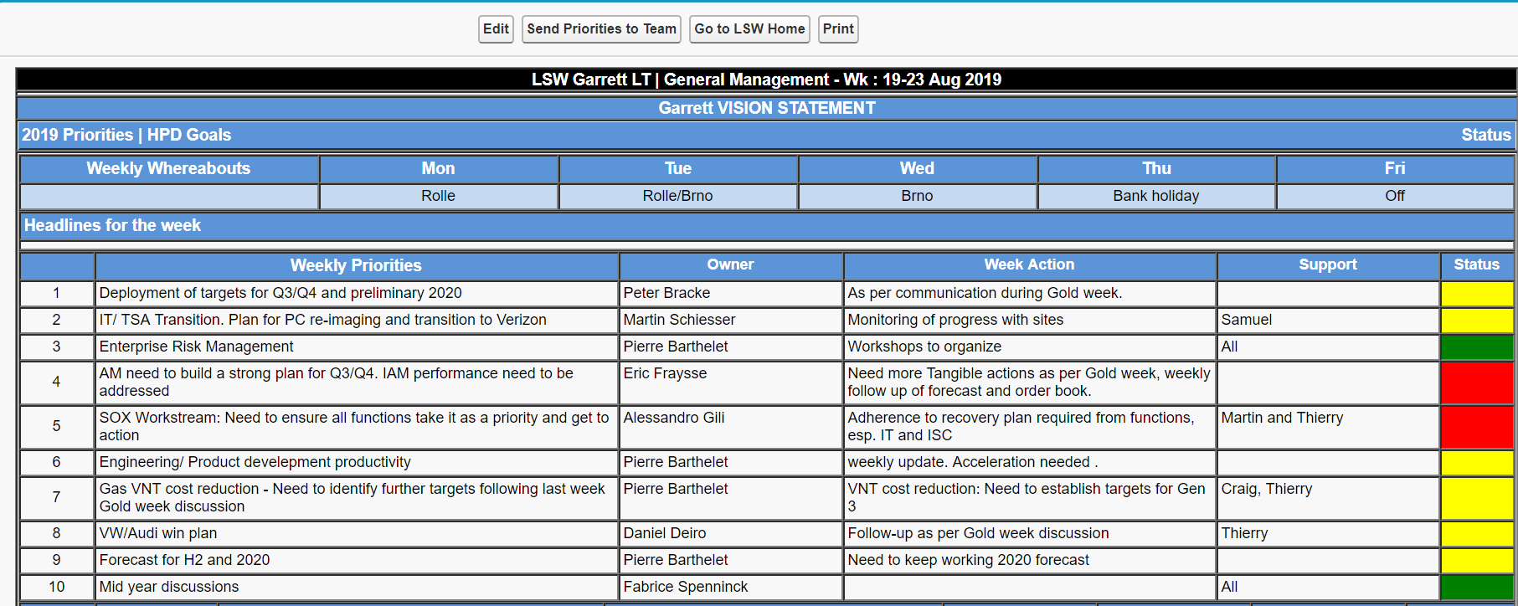

Appendix 4: Function Group maintenance for LSW

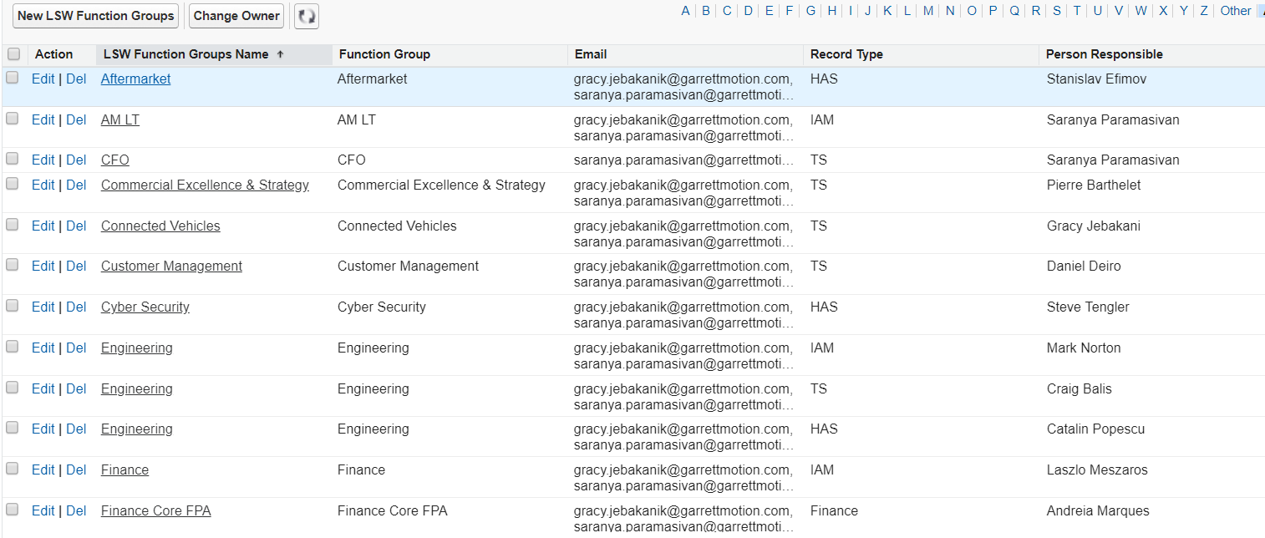

Appendix 5: Upload file to LSW
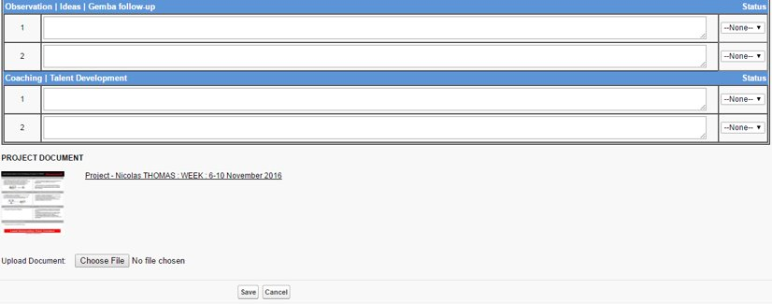

Appendix 6: Details in IAM Chatter.

